Global Coach Group

Global Coach Group (GCG) is a truly global leadership coaching organization integrating coaching with innovative technology services for a modern world. The changes in technology have not only changed organizational learning, leadership development and coaching but it has also changed how professionals lead and interact with their coworkers. At GCG we enable professionals to lead for good in the era of digitization.

Leaders and their interactions with coworkers are more in the open than ever before and that is why coaching needs to incorporate open-door approaches and transparency. Our coaching gives organizations clear visibility over what and how much their leaders are improving, and our methodology provides coaches with all the systems, tools, and technology they need to support leaders to go to the next level in their professional performance while engaging their teams.

With experience in a wide range of industries and organization levels across the world, our global network of coaches skillfully applies our highly effective yet bespoke coaching process across a wide range of languages, geographies, and cultural expertise. Furthermore, GCG provides unrivalled technology, a scalable coaching platform to ensure high-quality coaching and real-time visibility into results.
We work with high performers and high potential leaders to take them to the next levels of their leadership in today's VUCA (Volatile, Uncertain, Complex, and Ambiguous) world.

Lead for Good

Lead for Good is the belief and commitment that propels great leaders forward. True leadership adorns meaning only when it strives for the good of others. Fueled by the aspiration to become even better, today there are more than 1 million leaders who share our belief and strive to Lead for Good.

These leaders share our vision to be Good for People, Good for Progress and Good for Permanence.

Good for People
An effective leader guides their team to do what is right and supports them to grow, while ensuring alignment with the organization. These leaders help to pinpoint specific areas for development and coach their team members in ways that are authentic and constructive. Through this, they grow better together. Ultimately, this shapes the perception of coworkers positively, as they acknowledge this growth. For all to be engaged and to work cohesively together is at the core of that vision.
Good for Progress
Leaders work for progress to achieve meaningful results for themselves, their teams, their organization, and the clients they serve. Holistic progress in our rapidly changing world requires leaders to have the agility to adapt to the demands around them. Leaders who involve their coworkers in their leadership development journey have a 95% success rate, with one in three Fortune 500 companies having used this coaching process. The value this creates for progress is grounded in a coaching culture that relies on measurable growth.

Good for Permanence
Great leaders drive constructive change of behavior in ways that are sustainable and become part of their organizational culture. The forward momentum and enduring habits of one become rooted in the culture, establishing permanence and engagement throughout. The impact these leaders make is fueled by the transparency of their actions and their foundational mission for the greater good of people. Healthy leadership is something that benefits one and all, both in the short-term, and in the long run.

360 Feedforward Coaching Process
The 360 Feedforward Coaching process is a transparent process that guarantees measurable leadership growth.

Though most successful leaders/managers today have a good intellectual understanding of the various management tools required to lead an organization successfully, experience has shown that the same behaviors that contribute to initial career success often do not guarantee future leadership success. Whereas executive development and coaching programs generally focus heavily on (intellectual) learning and little on follow-through and measuring tangible results, 360 Feedforward Coaching has turned this on its ear with a strong emphasis on implementation and follow-through to measure growth in leadership effectiveness.

Our approach to leadership development and coaching is highly successful. That's by design! We place a strong emphasis on involving coworkers, implementing change, and follow-through to measure growth in leadership effectiveness. After all, what really counts is the leadership growth and who will see that better than the people you work with? We know, from experience that, "Leadership change is simple but not easy!". And the 360 Feedforward Coaching is a highly effective, transparent, bespoke, and time-efficient process that works all the time.
In the end, the only thing that counts is leadership growth i.e. improved leadership (behavior) effectiveness on the job as perceived by coworkers.

Hereunder is a more detailed step by step outline of how a typical coaching process is structured, which is often customized to fit the needs of the leader and the organization.

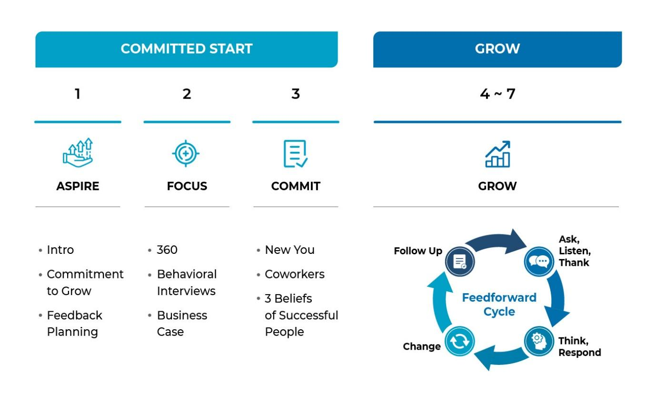

1. Aspire (+ 2 hours)
Change isn't an obstacle but, rather, an invitation to rise to the next level in of the leadership journey. That's why we start by guiding the leader towards the direction they want to grow. By describing their leadership journey and articulating their personal leadership model, we create a blueprint for the leader they'll grow to be. This helps them commit to the process because the journey, and the benefits, are entirely tailor made.

2. Focus (+ 2 hours)

With guidance and support from a coach, leaders then choose two specific areas for their leadership growth (e.g. empowerment and decision making) journey. Behavioral interviews and multi-rater leadership assessments (180° - 360°) are tools Coaches utilize to help leaders determine the best direction for their development.
Behavioral Interviews (10-15 hrs)
Structured in-depth behavioral interviews with the most important people around the leader produce a detailed & colorful overview with real life examples of strengths and areas for development.

Global Leader Assessment (GLA360) by Global Coach Group
The multi-rater assessment provides objectivity and structure to the assessment process and aside from relevant psychometrical content, it creates buy-in from the leader.

The GLA360 includes all relevant leadership skills to measure the effectiveness of leaders operating in an international business environment. This unique assessment developed by Accenture in collaboration with 200 international organizations on 6 continents measures skills related to leadership communication, managing diversity, global & strategic thinking, leading change, technology savviness, engaging people and much more which competencies modern leaders require to succeed in a globalizing business world.

3. Commit (+ 2 hours)

Once leaders can translate how their growth focus will powerfully impact themselves, their teams, and their business performance we widen the circle. This is when we invite coworkers to play a vital role in the leadership development journey. Leaders never walk alone.

4. Grow (+ 2 hours)

Coworkers Onboarding
Leadership growth is not a cognitive process but a daily creation of new behaviors and refinement of existing habits on the job. Coworkers facilitate the leadership growth process as the coworkers:
- Are experts in their respective fields and as they interact with the leader frequently, they should be in a position to provide solid and practical action suggestions in the predetermined leadership growth areas.
- Function as quasi accountability partners towards the leader in the leadership growth process. Since the coworkers are an integral part of the operation of the leader, the coworkers should subscribe to support leadership change.
- Are on the receiving end of the leader’s behavior. They are in an excellent position to assess growth in leadership effectiveness over time. Their perception is reality!
The leader supported by the coach will explain the coworkers their role in the coaching process and solicit their support in leadership change for the leader and the team.
Leading Change Involving Coworkers - Monthly coaching and action planning sessions
The 360 Feedforward Coaching process is based on a highly effective and time efficient feedforward process which engages coworkers in leadership change. The leader will use this feedforward process as their foundation for their monthly interaction with coworkers to manage leadership change and improve their leadership effectiveness and that of the team.
The aforementioned steps get the momentum in the leadership change process going. Based on the monthly feedforward suggestions from the coworkers, the leader supported by the coach, completes a monthly action plan that the leader wants to commit to. The remainder of the coaching sessions focuses on skill development and overcoming leadership change challenges mostly, related to coworker management or dealing with other organizational issues. Throughout this process the coach operates as a soundboard & accountability partner on one hand, and knowledge / experience resource provider (as well as coworker advocate) on the other hand. The process of consistent and regular follow-through is a key contributor to leadership growth and improved effectiveness, resulting in a changed perception of coworkers at the same time (see tables below based on research with 86,000 participants).

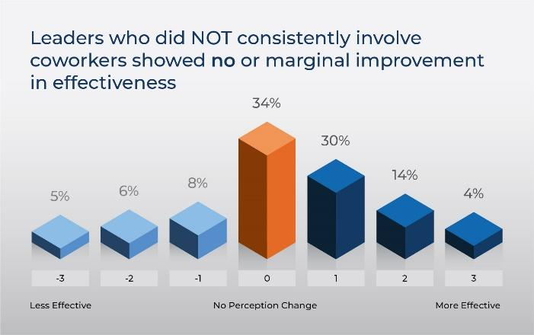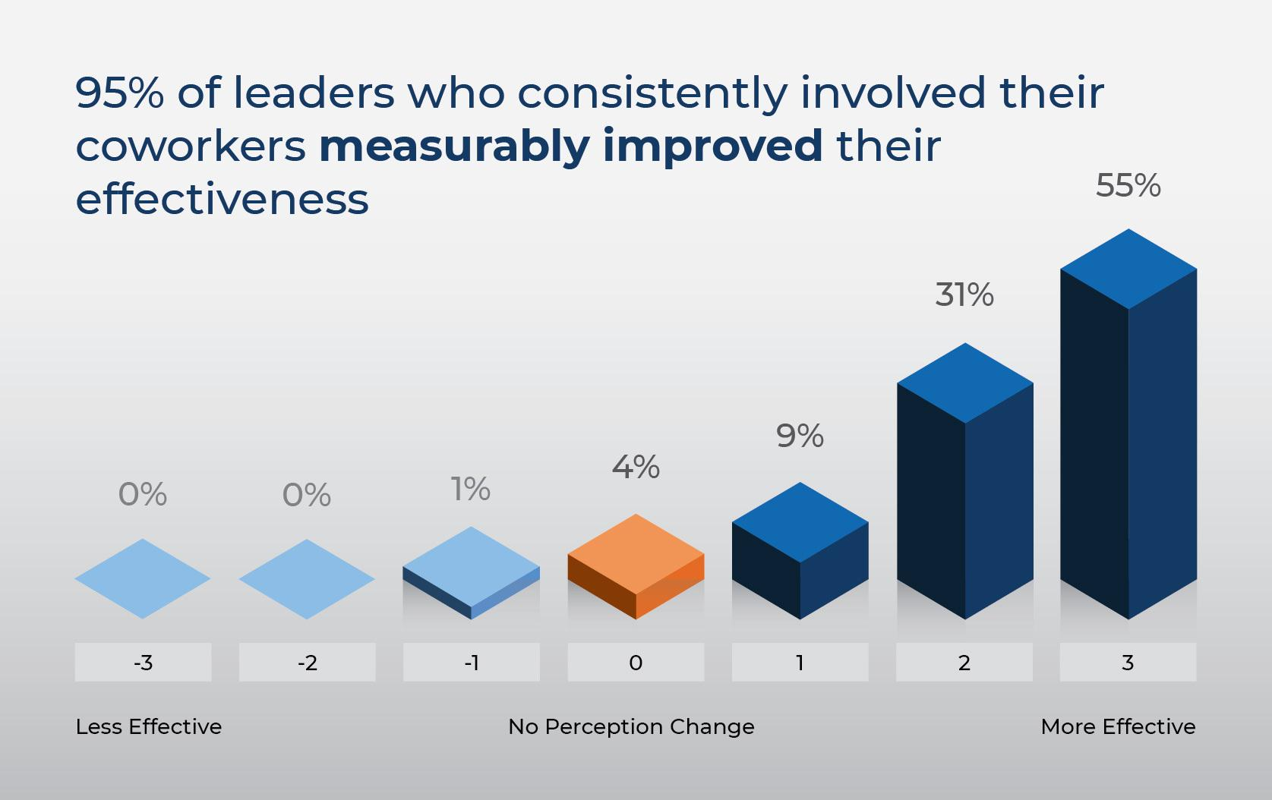
Results from 86,000 participants on 6 continents (Research: ‘Leadership is a contact sport’)

Leadership Growth Progress Reviews (LGPR)

After 5, 8 and 11 months into the process we collect the opinions of the coworkers to understand & measure their perception of the leader’s growth in the 1-2 leadership growth areas as determined at the outset of the process. At these points in time, the leader can evaluate their progress and identify areas for continued focus. At the end of the yearlong coaching program the final LGPR results are used to measure leadership growth and determine payment of coaching fees.

Leader as Coach

Throughout the year long behavioral coaching program, the leader has mastered the process and discipline to incorporate the 360 Feedforward Coaching process into their personal leadership style to coach themselves and their direct reports. This should result in the continuous acceleration of leadership success without the requirement of a coach so that the leader becomes even more of a coach to their direct reports. A truly powerful system that drives organizational performance and culture change.

Next level Leaders Lead for Good

Leadership growth and improving effectiveness take place at work while interacting with coworkers!
Most successful leaders / managers today have a good intellectual understanding of the various management tools & skills required to lead an organization successfully. Therefore, the major leadership challenges for managers and executives today is NOT understanding the practice of leadership BUT practicing their understanding of leadership. For successful organizational leaders to become more effective, leadership change needs to be positive, sustained, recognized, and acknowledged by their coworkers (and others).

360 Feedforward Coaching is a real time on the job process that is highly effective and time efficient. Accelerating leadership growth and effectiveness is about changing behaviors and creating new processes & habits while interacting with others (coworkers) on the job.

Awareness and Acceptance is not enough!
Coaching frequently focuses on assessing leadership effectiveness and action planning which results in a strong emphasis on awareness and acceptance. As a result, the leader intellectually understands where leadership change would be desirable and how leadership change would lead to higher effectiveness. Though this step is critical at the outset of the coaching process as it defines the 'intent of the leader to change', it oftentimes results in a long list of good action intentions that might not see the light of day.

Action and Acknowledgement is key!
360 Feedforward Coaching takes the leadership change process further, outside the leader's office, and into their work environment with the coworkers. Coworkers can provide important and insightful suggestions for behavioral change that would help leaders to become more effective on the job. The 360 Feedforward Coaching process includes a strong emphasis on action implementation and follow-through to make change stick, thus creating more effective leadership behaviors and habits. Leadership growth has only real value though implementing change that is sustained, recognized, and acknowledged by coworkers in the workplace. Perception is reality.

360 Feedforward Coaching for leadership growth

The efficacy of involving coworkers in coaching and leadership development has been clearly demonstrated:
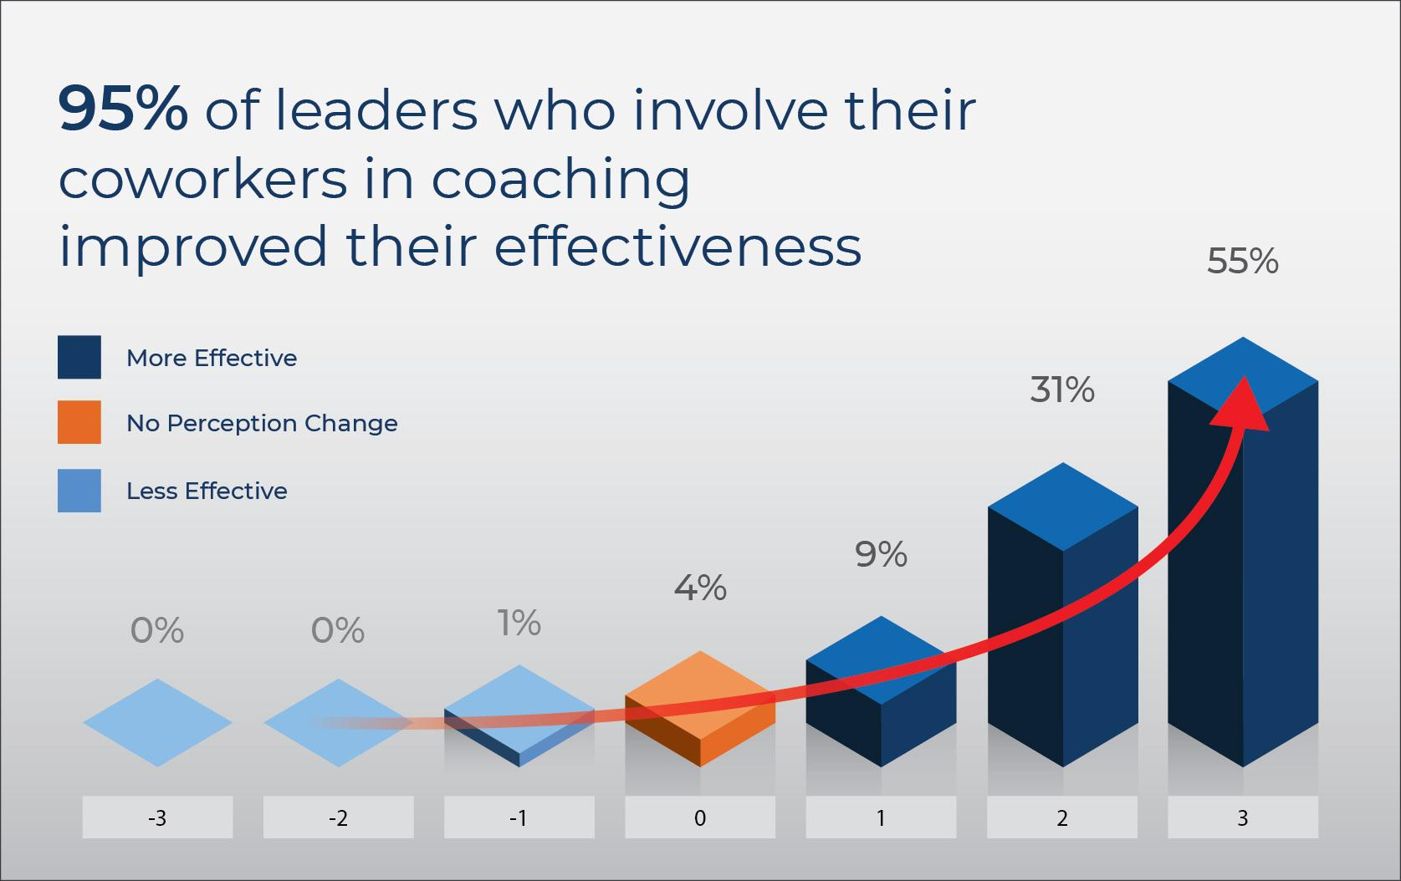
- A comprehensive study among 86,000 participants on 6 continents concluded that 95% of leaders who consistently involved coworkers in their coaching journey measurably improved their leadership effectiveness.
- Numerous great top executives, leadership thought leaders and HR development professionals have firsthand experience in working with Global Coach Group and the 360 Feedforward Coaching for themselves and their organizations.
- 360 Feedforward Coaching does not require any 'extra valuable time' from busy business executives as the coaching and leadership change process is integrated in their leadership role on the job.
- 360 Feedforward Coaching programs include a ‘No Growth No Pay’ success guarantee. Our commitment is to support leaders to become more effective in their organization, which is demonstrated in our coaching service fee structure where 50% to 100% of the coaching fees (for the yearlong programs) are subject to measurable growth in leadership effectiveness of the leaders as assessed by coworkers.

Global Team Coaching

The team coaching programs have proven to be highly effective and resource efficient in supporting leaders with their leadership growth and improving team effectiveness at the same time. Thus team coaching engagements create measurable leadership growth for the leader as well as for the team as a whole, involving coworkers in the process.

Global Team Coaching programs are typically structured as follows (min. 5 team members):
- 2 days team coaching workshop to initiate the coaching and leadership growth process
- Monthly Team Coaching and Action Planning sessions (2-3 hours per session). This includes time for focused skill development as it relates to their leadership growth areas. During the coaching sessions the coach who works with every team member individually and/or with the team as a whole (depending on the team coaching program selected).
- 3 Quarterly Leadership Growth Progress Reviews.
The various team coaching programs are based on the same highly effective process as the 1-on-1 coaching engagements and have been adapted to fit a team environment and related team objectives. This allows for applying Guaranteed & Measurable Leadership Growth also in team coaching.

Advantages of team coaching:
- Changing leaders and teams at the same time The team as a whole articulates one leadership growth area and each team member defines their own leadership growth area that relates to the team focus. This creates an interdependent team effort with a common focus on producing results for their individual effectiveness and team productivity simultaneously.
- Insider expertise Team members should be in a position to provide expert advice and an insider view to each other as it relates to their business, their people, and their team culture challenges. They become de facto coaches.
- Openness to continuous change When team members collaborate as coworkers in the team coaching programs, it creates an open culture for leadership and team culture change. Furthermore, team members feel comfortable to use feedback and Feedforward around the organization to drive change for themselves and their teams.
- Coaching is a leadership skill Many organizations use coaching as an 'executive intervention' or to 'fix a problem', but this is a suboptimal approach to coaching. Coaching is a leadership skill and leaders in organizations should be skilled coaches to help their teams develop and grow. Same as we expect effective leaders to be highly skilled in e.g. communication, decision making and empowerment, leaders should be highly skilled in coaching others. team coaching is a great program to instill coaching as a leadership skill in the organization.
- Resource efficient Since one executive coach works with all team members supporting each other in this team coaching process the whole coaching program is very time efficient and reduces coaching fees per team member.

As thinking about and intending to change are not the same as actual change in behavior acknowledged by coworkers, coaching for leadership growth and team effectiveness is a lot about 'a disciplined process of implementation' and not about 'participating in coaching workshops'. An important part of team coaching is team members supporting each other as coworkers and coaches, while implementing their action plans to make change visible. Therefore, this program is ideally suited for leaders and their (cross functional / project) teams to measurably change their individual and collective effectiveness as they lead and develop their teams, and at the same time develop their coaching skills to further role out this coaching process with their direct reports. team coaching can be a very effective and cost-efficient way to grow leaders, change teams and develop the organizational culture.

Global Team Coaching – 2 Day Workshop

Objectives:
- Leveraging 360 Feedforward Coaching to enhance leadership & team effectiveness.
- Define interconnected leadership growth areas for the team and each team member
- Creating buy-in from team members in being coached as well assessing their coachability.
- Overcoming obstacles in coaching and creating a culture of continuous change, growth and improvement.
- Growing coaching expertise as a leadership skill to implement a system for continuous leadership growth for themselves and the team as a whole.

Day 1 – Defining the Team Development & Leadership Journey

09:00 Introduction to 360 Feedforward Coaching (30 mins)
The 360 Feedforward Coaching process involving coworkers guarantees measurable leadership growth for each team member. Global Coach Group Global Team Coaching is an extremely powerful approach to accomplish leadership growth through behavioral change. The leaders will use this process as a basis for their interaction with team members and other coworkers.

09:30 Authentic Leadership builds Leadership Brand (180 mins)
Leaders combine their personal values and role model examples with the Global Leadership competencies and define their authentic leadership model as well as their personal leadership brand. This creates a very powerful aspirational leadership model for the leaders that drives their leadership change into action throughout the workshop and during the entire yearlong coaching process.

14:00 MY Leadership Journey (180 mins)
The Global Leadership Assessment report guides leaders to review their leadership effectiveness. To complement their personal assessment results, leaders interview each other using the impactful ‘Do More & Do Different” exercise. Leaders guide each other with real life illustrations on improving their professional leadership style and team role with the objective to become a more valuable leader while supporting the development of the team. This powerful feedback process helps leaders to determine their leadership growth area to accelerate their leadership as well as making a valuable personal business case 'What's In It For Me'.

17:15 Consolidate learnings on coaching & leadership growth (30-45 mins)

18:00 End of the program Breaks: 10:30 (15 min), 13:00 (1 hr), 15:30 (15 min)

Day 2 – Leading Team Development Involving Coworkers
09:00 OUR Team Development Journey (120 mins)
Based on the aforementioned input and their knowledge on global leadership & constructive team behaviors, leaders select and articulate the behavioral changes that would significantly improve their leadership & team effectiveness. The team selects one team growth area and each team member aligns their one leadership growth area to the team focus. At the same time the leaders and the team define the impact and benefits this change will produce for the team and the business which will serve as a valuable team business case 'What's In It For Us'. This ensures that maximum buy-in and impact is created for each leader and the team as a whole.

11:15 Leveraging Team Members as Peer Coaches (15 mins)
Team members will choose a peer coach from their team and they will commit to coach each other throughout this process. This will help leaders to become better coaches and it will help leaders to understand what it means to be coached at the same time.

11:30 Commitment to Grow (60 mins)
Leveraging the paradigms for successful leaders the participants assess their Commitment to Grow and articulate their level of commitment to leadership change.

12:30 Leading team Development Involving Coworkers – 7 step process (30 mins)
To mobilize change team members will be introduced to the monthly seven process where leaders involve coworkers using a 7-step process to change behavior and perception at the same time.

14:00 Leading Change Involving Team Coworkers (60 mins)
Changing behavior is not a cognitive process but a daily effort to implement new behaviors and refine existing habits on the job. Coworkers facilitate the change process as they function as quasi accountability partners for the leader in the leadership growth process and as an integral part of the team, they will support leadership change.

15:00 Leveraging Feedforward (60 mins)
The leaders will coach each other providing Feedforward suggestions that drive team and leadership change in the earlier selected growth areas. This constructive, future focused process generates excellent ideas to kick start change on a personal and team level.

16:15 Monthly Action Planning (MAP) for Change (45 mins)
Leaders supported by their peer coach as appropriate, work to construct a Monthly Action Plan for improvement in the targeted leadership growth areas.

17:00 Leading Change to Change Perception (30 mins)
Leaders will become familiar with the seven coaching skills required to accelerate leadership growth and effectiveness. The change in the leader's behavior needs to result in a change in perception of the coworkers. Perception is reality!

17:30 Measuring change using the Leadership Growth Progress Reviews (15 mins)
The Leadership Growth Progress Reviews provide an objective perception of the leadership progress as observed by the coworkers, which information the leader can use in evaluating the recent action implementation and its impact on results. Perception is reality!

17:45 Consolidate learnings on coaching & leadership growth (15 mins)
18:00 End of the program Breaks: 10:30 (15 min), 12:30 (1 hr), 15:30 (15 min)

Monthly Team Coaching Sessions – 2 - 3 hours

The monthly team coaching sessions keep the momentum going in the leadership growth and change process. At the same time the team members learn from each other and share best leadership practices that are effective in their specific business and organizational culture environments. A Certified Coach facilitates the process, provides insights, and guides the leaders in their leadership development journey. During these monthly coaching sessions, the leaders also hone their coaching skills.

Following the monthly coaching sessions, leaders have a clear and ambitious action plan for the next 30 days, to work towards further improving their leadership effectiveness in the defined areas of leadership growth. This approach creates practical applications for the coaching and leadership growth process and assures that the leaders, the team and their coworkers reap immediate value every month.

09:00 Monthly Action Planning (MAP) to implement leadership growth (60 – 90 mins)
During the monthly coaching sessions each leader:
- Follows up with team members (and other coworkers) to gather Feedforward suggestions.
- Completes their personal GDD review (Good – Difficult – Different) to assess what is working well and where their bottlenecks are in the leadership growth process.
- Revises their Monthly Action Plan (MAP) for the next 30 days.
Each leader works together with their peer coach (or another team member) to review and to refine the monthly action plan and works to alleviate issues that hamper their leadership growth process.

10:30 Leadership skills development focus (60-90 mins)
Each coaching session will also focus on a specific skill development for the leaders as it relates to their areas of leadership growth as team or as a leader. This helps the leaders apply new ideas and processes in the workplace and discuss its application during the coaching session. Typically, leaders select leadership skills areas as:
- Coaching skills
- Decision making (incl. speed and incorporating opinions of others in decision making)
- Communication (incl. listening)
- Conflict management
- Influencing
- Delegation / Empowerment of direct reports
- Managing diversity
- Cross cultural management (incl. communication)
- Being more entrepreneurial
- Execution for results
- Holding others accountable for results
- Collaborate better with others (incl. being more respectful to others)
- Building trust with coworkers
- Standing up to individuals who undermine teamwork
- Self-confidence
- Focusing execution and resources on few business-critical issues
- Becoming more assertive (incl. speaking up for own beliefs & opinions)
- Taking calculated risks
- Building cross-functional relationships
Subjects will be selected based on the team and leadership growth foci determined at the outset.
12:00 End of the program

Leadership Growth Progress Reviews (Quarterly)

Organizations tend to spend too much emphasis on training and too little on follow-through!
Application of learnings on the job and measuring results through follow up creates real value for the leaders being coached, their teams and the organization. As the adage goes: You can only manage what you can measure! Leadership Growth Progress Reviews (LGPR) provide the leaders being coached and the team with valuable genuine feedback from the coworkers on actual progress in leadership and team effectiveness (i.e. the unvarnished truth straight from the horse’s mouth).

On a quarterly basis the monthly coaching session will include the review of the LGPR results where leaders review and discuss their coaching challenges and get coaching input from one or more team members. These workshops help the leaders to improve their coaching and leadership skills in a practical and professional manner and build team cohesion. In essence, the LGPR also serves as a ‘reality check’, ‘moment of truth’ and ‘catalyst for change’.

The LGPR reviews include:

Looking back
Using the recent GDD Assessment (Good – Difficult – Different) the leaders will review successes and obstacles to determine the next bottleneck(s) to focus on.

Taking Stock
Following the conclusions from the aforementioned and the Leadership Growth Progress Review, leaders will determine which leadership processes and/or team skills to improve. This provides further focus in enhancing leadership and team effectiveness.

Moving forward
Leaders and team members coach and support each other in setting their quarterly objectives and making their monthly action plans. The interaction among the leaders stimulates their minds, aligns initiatives across the team and supports accountability for action execution and results.

Leader as Coach - Leveraging 360 Feedforward Coaching – 1 Day Workshop

Objectives:
- Leveraging 360 Feedforward Coaching to enhance leadership effectiveness.
- Define leadership growth areas for each leader and articulating their business case for change
- Creating buy-in from leaders in being coached as well assessing their coachability.
- Growing coaching expertise as a leadership skill to implement a system for continuous leadership growth.

09:00 Introduction to 360 Feedforward Coaching (60 mins)
360 Feedforward Coaching is an extremely powerful seven-step approach to accomplish leadership growth through behavioral change. The leaders will use this process as a basis for their interaction with other coworkers.

10:00 Building Leadership Brand using Authentic Leadership (105 mins)
Based on the Global Leadership competencies, leaders define their authentic leadership model and their personal leadership brand. This creates a very powerful aspirational leadership model for the leaders that drives their leadership change into action.

13:30 Assessing Leadership Growth Areas (60 mins)
Leaders will interview each other using the impactful ‘Do More & Do Different’ exercise. Through this process they guide each other on improving their leadership style and coaching role with the objective to become a more valuable leader while supporting others in their development.

14:30 Creating the Business Case for Leadership Growth (30 mins)
Using the interview data and their authentic leadership model leaders articulate 1-2 leadership growth areas that would significantly improve their leadership effectiveness. At the same time the leaders define the impact and benefits this change will produce for themselves and their business.

15:15 Leading Change Involving Coworkers (30 mins)
Changing behavior is not a cognitive process but a daily effort to implement new behaviors and refine old habits on the job. Coworkers facilitate the change process as they function as quasi accountability partners in the leadership growth process.

15:45 Leveraging Feedforward (45 mins)
The leaders will solicit Feedforward suggestions that drive leadership change in the earlier selected growth areas. This constructive, future focused process generates excellent ideas to kick start leadership change.

16:30 Monthly Action Planning (MAP) for change (45 mins)
Leaders supported by their peer coach as appropriate, work to construct a Monthly Action Plan for improvement in the targeted leadership growth areas.

17:15 Measuring change using the Leadership Growth Progress Reviews (45 mins)
The Leadership Growth Progress Reviews provide an objective perception of the leadership progress as observed by the coworkers. Perception is reality!

18:00 End of the program Breaks: 10:30 (15 min), 12:30 (1 hr), 15:30 (15 min)

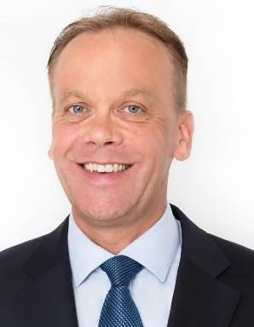
Will Linssen, MBA, MSc

"Making Change Happen for a Triple Win” is the foundation based on which Will provides top executives with effective business solutions and practical leadership applications that deliver measurable results for their specific organizational challenges, resulting in a triple win for leaders, their teams and their business. Will has more than 30 years of in-depth experience in executive positions and managing businesses in Europe, North America, and Asia. After his executive leadership career, Will built the world’s #1 international coaching network which evolved into the Global Coach Group (GCG) where he is currently the CEO.

Professional Experience
Will has been recognized as World’s #1 Coach Trainer by Thinkers50 (UK) and Top 10 Global Leadership Coach by Global Gurus (USA) and Harvard University invited him as a member of their Institute of Coaching. Furthermore, Will is one of the first Master Certified Coaches at Marshall Goldsmith Stakeholder Centered Coaching. For over two decades he has been working with executive teams to measurably improve their leadership and organizational effectiveness. He has held several positions in general management and business management at multinational companies in Europe, North America, and Asia and he has served at the board of several multinationals in Asia. Will travels the globe training executive coaches and coaching business leaders in using GCG’s highly effective methodology.
Clients consistently commend his results-driven personality combined with his confident, energetic, and relatable style. A good listener and problem solver with in-depth business knowledge and cross-cultural understanding, he has been recognized for his creative and analytical skills, and most of his executive clients hold international positions in a wide range of industries at Fortune 500 Cos across USA, LATAM, Europe, Asia, and Australia a.o. AON, Allianz, BAT, Bayer, Coca Cola, GSK, ING, Kimberly Clark, LG, LinkedIn, McDonalds, Novartis, Pepsi, Philips, Philip Morris, Sanofi, Standard Chartered Bank, Syngenta, SC Johnson and Uber.
Qualifications & Accreditations

Will holds two Master’s degrees in Technology Management and Business Administration from IMD (Switzerland).
Will has earned a number of well recognized professional HR development accreditations in the field of leadership, executive coaching, and assessments by reputed international organizations such as:
- Stakeholder Centered Coaching (Master Certified Coach (MCC)) for 1-on-1 Executive Coaching, Team Coaching, and Global Leadership Assessment.
- Organizational & leadership development assessments from Human Synergistics
- Emotional intelligence leadership from Daniel Goleman / Korn Ferry
- Seven Habits of Highly Effective People from FranklinCovey
- Team collaboration & managing diversity from Belbin
- Personality typing tools such as MBTI from CPP and Predictive Index from PI International
- Executive performance management from HeartMath
Publications

Will has written various leadership books and coaching certification programs, most notably:
- Next Level Leader, Lead for Good
- Global Leadership Assessment (GLA 360)
- Global Leadership Coaching, Coach Guide
- Global Team Coaching, Coach Guide
“Will Linssen combines incredible subject matter expertise with excellent skills in the area of leadership development and executive coaching. He is highly sensitive to cultural differences from an innate understanding and true appreciation of what is beneath the surface which enables him to build a bridge between Asian and Western management styles. He is more focused on getting results than anyone I have worked with in the management development community before and delivers!”

Arthur van Benthem, CEO BrandLoyalty International

Partial List of Clients

ABL Insurance
Abu Dhabi Polymers
Agilent Technologies
Allianz
Allergen
Amazon
American Express
AON Hewitt
Applied Materials
ASM
AT&T
Bayer
BAT
Blizzard
BMS
Borouge
Cisco
Citibank
Coca Cola
Daimler
Expedia
GE
Grab
GSK
Hasbro
HP
Hyatt
IBM
ING
Intel
LG
LinkedIn
Logitech
McDonald's
Microsoft
Novartis
Johnson & Johnson
KPMG
Kimberly-Clark
On Semiconductor
Pepsico
Philips
Philip Morris
Pure Storage
Qualcomm
Reebok
Sandoz
Sanofi
Saudi Telecom
SC Johnson
Siemens
Standard Chartered Bank
Syngenta
Solvay
Toyota
Uber
USG Boral
UBS
Whirlpool

3500 Coaches – 200 Cities – 55 Countries – 35 Languages – ONE Process

At present Global Coach Group has more than 3500 certified coaches around the world. This vast cadre of experienced executive coaches is a great asset for our clients who can select coaches from various backgrounds and levels to fit their coaching needs.

Global Coach Group Locations
